Dynamic Programming
(Ch. 16, "Introduction to Algorithms", 1st Ed. by T. Cormen, C. Leiserson & R. Rivest).

Dynamic programming, like the divide-and-conquer method, solves problems by combining the solutions to sub-problems.

("Programming" in this context refers to a tabular method, not to writing computer code.)

As we saw in Chapter 1, divide-and-conquer algorithms partition the problem into independent sub-problems, solve the sub-problems recursively, and then combine their solutions to solve the original problem.

In contrast, dynamic programming is applicable when the sub-problems are not independent, that is, when sub-problems share sub-sub-problems.

In this context, a divide-and-conquer algorithm does more work than necessary, repeatedly solving the common sub-sub-problems.

A dynamic-programming algorithm solves every sub-sub-problem just once and then saves its answer in a table, thereby avoiding the work of recomputing the answer every time the sub-sub-problem is encountered.

Dynamic programming is typically applied to optimization problems.

In such problems there can be many possible solutions.

Each solution has a value, and we wish to find a solution with the optimal (minimum or maximum) value.

We call such a solution an optimal solution to the problem, as opposed to the optimal solution, since there may be several solutions that achieve the optimal value.

The development of a dynamic-programming algorithm can be broken into a sequence of four steps.

1. Characterize the structure of an optimal solution.

2. Recursively define the value of an optimal solution.

3. Compute the value of an optimal solution in a bottom-up fashion.

4. Construct an optimal solution from computed information.

Steps 1-3 form the basis of a dynamic-programming solution to a problem.

Step 4 can be omitted if only the value of an optimal solution is required.

When we do perform step 4, we sometimes maintain additional information during the computation in step 3 to ease the construction of an optimal solution.

The sections that follow use the dynamic-programming method to solve some optimization problems.

- We will show how we can multiply a chain of matrices so that the fewest total scalar multiplications are performed.

- Given this example of dynamic programming, we will discuss two key characteristics that a problem must have for dynamic programming to be a viable solution technique.

- Then we will show how to find the longest common subsequence of two sequences.

- Finally, we will show uses dynamic programming to find an optimal triangulation of a convex polygon, a problem that is surprisingly similar to matrix-chain multiplication.

16.1 Matrix-chain multiplication

Our first example of dynamic programming is an algorithm that solves the problem of matrix-chain multiplication.

We are given a sequence (chain) ⟨A₁,A₂ ,. . . A_{n} ⟩ of n matrices to be multiplied, and we wish to compute the product

A₁A₂ . . . A_{n}

We can evaluate the expression (16.1) using the standard algorithm for multiplying pairs of matrices as a subroutine once we have parenthesized it to resolve all ambiguities in how the matrices are multiplied together.

A product of matrices is fully parenthesized if it is either a single matrix or the product of two fully parenthesized matrix products, surrounded by parentheses.

Matrix multiplication is associative, and so all parenthesizations yield the same product.

For example, if the chain of matrices is ⟨A₁,A₂,A₃,A₄⟩ , the product A₁A₂A₃A₄ can be fully parenthesized in five distinct ways:

(A₁(A₂(A₃A₄))) ,

(A₁((A₂A₃)A₄)) ,

((A₁A₂)(A₃A₄)) ,

((A₁(A₂A₃))A₄) ,

(((A₁A₂)A₃)A₄) .

The way we parenthesize a chain of matrices can have a dramatic impact on the cost of evaluating the product.

Consider first the cost of multiplying two matrices.

The standard algorithm is given by the following pseudocode.

The attributes rows and columns are the numbers of rows and columns in a matrix.

MATRIX-MULTIPLY (A, B)

1. if columns[A] ≠ rows[B]
2. then error "incompatible dimensions"
3. else for i ←1 to rows[A] do
4. for j ←1 to columns[B] do
5. C[i,j] ← 0
6. for k ← 1 to columns[A] do
7. C[i,j]←C [i,j]+A[i,k]. B[k,j]
8. return C

We can multiply two matrices A and B only if the number of columns of A is equal to the number of rows of B.

If A is a p x q matrix and B is a q x r matrix, the resulting matrix C is a p x r matrix.

The time to compute C is dominated by the number of scalar multiplications in line 7, which is pqr.

In what follows, we shall express running times in terms of the number of scalar multiplications.

To illustrate the different costs incurred by different parenthesizations of a matrix product, consider the problem of a chain ⟨A₁,A₂,A₃⟩ of three matrices.

Suppose that the dimensions of the matrices are

10 x 100, 100 x 5, and 5 x 50, respectively.

If we multiply according to the parenthesization ((A₁A₂)A₃), we perform
10*100*5 = 5,000 scalar multiplications

to compute the 10x5 matrix product A₁A₂, plus another

10*5*50 = 2,500 scalar multiplications

to multiply this matrix by A₃, for a total of 7500 scalar multiplications.

If instead we multiply according to the parenthesization (A₁(A₂A₃), we perform

100*5*50 = 25,000 scalar multiplications

to compute the 100 x 50 matrix product A₂A₃, plus another

10*100*50 = 50,000 scalar multiplications

to multiply A₁ by this matrix, for a total of 75,000 scalar multiplications.

Thus, computing the product according to the first parenthesization is 10 times faster.

The matrix-chain multiplication problem can be stated as follows: given a chain ⟨A₁,A₂, ..., A_{n}⟩ of n matrices, where for i = 1, 2,. . . , n, matrix A_{i} has dimension p_{i-1} x p_{i}, fully parenthesize the product A₁A₂ . . .A_{n} in a way that minimizes the number of scalar multiplications.

Counting the number of parenthesizations

Before solving the matrix-chain multiplication problem by dynamic programming, we should convince ourselves that exhaustively checking all possible parenthesizations does not yield an efficient algorithm.

Denote the number of alternative parenthesizations of a sequence of n matrices by P(n).

Since we can split a sequence of n matrices between the k^{th} and (k + 1 )^{st} matrices for any k = 1, 2,. . ., n-1 and then parenthesize the two resulting subsequences independently, we obtain the recurrence

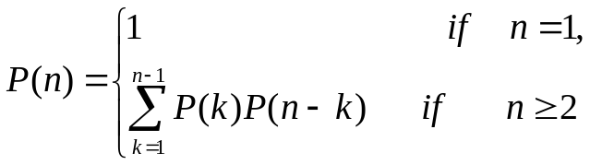

The solution to this recurrence is the sequence of Catalan numbers:
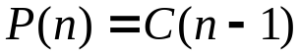
where
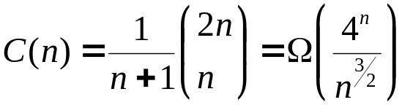

The number of solutions is thus exponential in n, and the brute-force method of exhaustive search is therefore a poor strategy for determining the optimal parenthesization of a matrix chain.

The structure of an optimal parenthesization

The first step of the dynamic-programming paradigm is to characterize the structure of an optimal solution.

For the matrix-chain multiplication problem, we can perform this step as follows.

For convenience, let us adopt the notation A_{i}.._{j} for the matrix that results from evaluating the product A_{i}A_{i+1} . . .A_{j}.

An optimal parenthesization of the product A₁ A₂ . . . A_{n} splits the product between A_{k} and A_{k+1} for some integer k in the range 1 ≤ k < n.

That is, for some value of k, we first compute the matrices A₁.._{k} and A_{k+l..n} and then multiply them together to produce the final product A₁.._{n}.

The cost of this optimal parenthesization is thus the cost of computing the matrix A₁.. _{k} , plus the cost of computing A_{k+1..n}, plus the cost of multiplying them together.

The key observation is that the parenthesization of the "prefix" subchain A₁A₂... A_{k} within this optimal parenthesization of A₁A₂. . . A_{n} must be an optimal parenthesization of A₁A₂ . ...A_{k}. Why?

If there were a less costly way to parenthesize A₁A₂ . . . A_{k}, substituting that parenthesization in the optimal parenthesization of A₁A₂ . . .A_{n} would produce another parenthesization of A₁A₂ . . .A_{n} whose cost was lower than the optimum: a contradiction.

A similar observation holds for the parenthesization of the subchain A_{k+1} A_{k+2} . . .A_{n} in the optimal parenthesization of A₁A₂. . . . A_{n}: it must be an optimal parenthesization of A_{k+1} A_{k+2} . . . A_{n}.

Thus, an optimal solution to an instance of the matrix-chain multiplication problem contains within it optimal solutions to subproblem instances.

Optimal substructure within an optimal solution is one of the hallmarks of the applicability of dynamic programming, as we shall later.

A recursive solution

The second step of the dynamic-programming paradigm is to define the value of an optimal solution recursively in terms of the optimal solutions to subproblems.

For the matrix-chain multiplication problem, we pick as our subproblems the problems of determining the minimum cost of a parenthesization of A_{i}A_{i+1} ... A_{j} for 1 ≤ i ≤ j ≤ n.

Let m[i,j] be the minimum number of scalar multiplications needed to compute the matrix A_{i}.._{j}; the cost of a cheapest way to compute A₁..n would thus be m[1, n].

We can define m[i,j] recursively as follows.

If i = j, the chain consists of just one matrix A_{i}.._{i} = A_{i}, so no scalar multiplications are necessary to compute the product.

Thus, m[i, i] = 0 for i = 1,2,..., n.

To compute m[i, j] when i < j, we take advantage of the structure of an optimal solution from step 1.

Let us assume that the optimal parenthesization splits the product A_{i}A_{i+1}. .A_{j} between A_{k} and A_{k+1}, where i ≤ k < j.

Then, m[i, j] is equal to the minimum cost for computing the subproducts A_{i}.._{k} and A_{k+1}.._{j}, plus the cost of multiplying these two matrices together.

Since computing the matrix product A_{i}.._{k}A_{k+ 1}.._{j} takes
p_{i-1}p_{k}p_{j} scalar multiplications,

we obtain

m[i, j] = m[i, k] + m[k + 1, j] + p_{i-1}p_{k}p_{j}

This recursive equation assumes that we know the value of k, which we don't.

There are only j-i possible values for k, however, namely k = i, i + 1, . . . , j-1.

Since the optimal parenthesization must use one of these values for k, we need only check them all to find the best.

Thus, our recursive definition for the minimum cost of parenthesizing the product A_{i}A_{i+1} . . .A_{j} becomes

(16.2)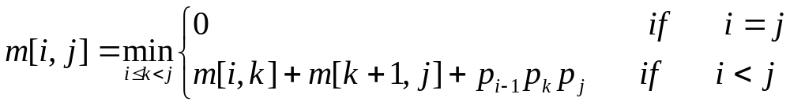

The m[i, j] values give the costs of optimal solutions to sub-problems.

To help us keep track of how to construct an optimal solution, let us define s[i, j] to be a value of k at which we can split the product A_{i}A_{i+1} . . .A_{j} to obtain an optimal parenthesization.

That is, s[i, j] equals a value k such that

m[i, j] = m[i, k] + m[k + 1, j] + p_{i-1}p_{k}p_{j}.

Computing the optimal costs

At this point, it is a simple matter to write a recursive algorithm based on recurrence (16.2) to compute the minimum cost m[1, n] for multiplying A₁A₂ . . . A_{n}.

As we shall see in a next Section, however, this algorithm takes exponential time, no better than the brute-force method of checking each way of parenthesizing the product.

The important observation that we can make at this point is that we have relatively few subproblems: one problem for each choice of i and j satisfying 1 ≤ i ≤ j ≤ n, or 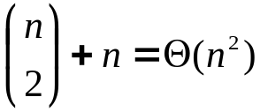 total.

A recursive algorithm may encounter each sub-problem many times in different branches of its recursion tree.

This property of overlapping sub-problems is the second hallmark of the applicability of dynamic programming.

Instead of computing the solution to recurrence (16.2) recursively, we perform the third step of the dynamic-programming paradigm and compute the optimal cost by using a bottom-up approach.

The following pseudocode assumes that matrix A_{i} has dimensions p_{i-1} x p_{i} for i = 1, 2,. . ., n.

The input is a sequence ⟨p₀,p₁,... ,p_{n}⟩, where length[p] = n + 1.

The procedure uses an auxiliary table m[1,.. n, 1.. n] for storing the m[i, j] costs and an auxiliary table s[1 . . n, 1 . . n] that records which index of k achieved the optimal cost in computing m[i, j].

MATRIX-CHAIN-ORDER(P)
1. n ← length[p] - 1
2. for i ← 1 to n do
3. m[i, i] ← 0
4. for l ← 2 to n do
5. for i ← 1 to n -l + 1 do
6. j ← i + l - 1
7. m[i, j] ← ∞
8. for k ← i to j - 1 do
9. q ← m[i, k] + m[k + 1,j] + p_{i-1}p_{k}p_{j}
10. if q < m[i,j]
11. then m[i,j] ← q
12. s[i,j] ← k
13. return m and s

The algorithm fills in the table m in a manner that corresponds to solving the parenthesization problem on matrix chains of increasing length.

Equation (16.2) shows that the cost m[i, j] of computing a matrix-chain product of j - i + 1 matrices depends only on the costs of computing matrix-chain products of fewer than j- i+ 1 matrices.

That is, for k = i, i+ 1, . . . ,j - 1, the matrix A_{i}.._{k} is a product of k - i + 1 < j - i + 1 matrices and the matrix A_{k+1}.._{j} is a product of j - k < j - i + 1 matrices.

The algorithm first computes m[i, i] ← 0 for i = 1, 2, . . ., n (the minimum costs for chains of length 1) in lines 2-3.

It then uses recurrence (16.2) to compute m[i, i + 1] for i = 1, 2,. . . , n - 1 (the minimum costs for chains of length l = 2) during the first execution of the loop in lines 4-12.

The second time through the loop, it computes m[i, i + 2] for i = 1, 2, . . ., n - 2 (the minimum costs for chains of length l = 3), and so forth.

At each step, the m[i, j] cost computed in lines 9-12 depends only on table entries m[i, k] and m[k + 1, j] already computed.

Figure 16.1 illustrates this procedure on a chain of n = 6 matrices.

Since we have defined m[i, j] only for i ≤ j, only the portion of the table m strictly above the main diagonal is used.

The figure shows the table rotated to make the main diagonal run horizontally.
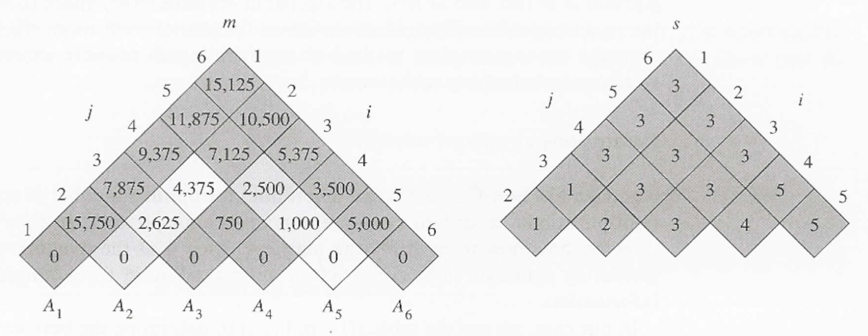
Figure 16.1 The m and s tables computed by MATRIX-CHAIN-ORDER for n = 6 and the following matrix dimensions:
matrix dimension
A₁ 30 x 35
A₂ 35 x 15
A₃ 15 x 5
A₄ 5 x 10
A₅ 10 x 20
A₆ 20 x 25

The tables are rotated so that the main diagonal runs horizontally. Only the main diagonal and upper triangle are used in the m table and only the upper triangle is used in the s table. The minimum number of scalar multiplications to multiply the 6 matrices is m[1,6] = 15,125. Of the lightly shaded entries, the pairs that have the same shading are taken together in line 9 when computing

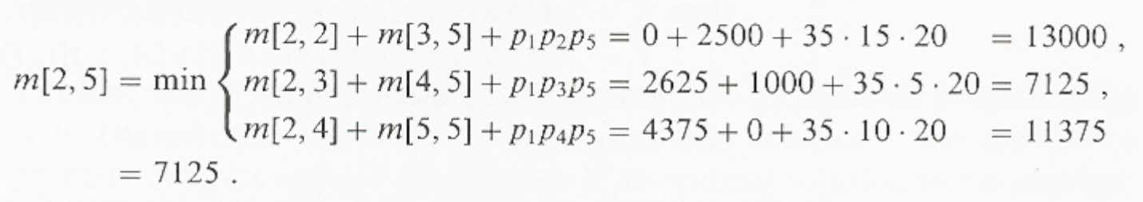

The matrix chain is listed along the bottom.

Using this layout, the minimum cost m[i, j] for multiplying a subchain A_{i}A_{i+1} . . .A_{j} of matrices can be found at the intersection of lines running northeast from A_{i} and northwest from A_{j}.

Each horizontal row in the table contains the entries for matrix chains of the same length. MATRIX-CHAIN-ORDER computes the rows from bottom to top and from left to right within each row.

An entry m[i, j] is computed using the products p_{i-1}p_{k}p_{j} for k = i, i + 1, . . ., j - 1 and all entries southwest and southeast from m[i, j].

A simple inspection of-the nested loop structure of MATRIX-CHAIN-ORDER yields a running time of O(n³) for the algorithm. The loops are nested three deep, and each loop index (l, i, and k) takes on at most n values.

The algorithm requires Θ(n²) space to store the m and s tables.

Thus, MATRIX-CHAIN-ORDER is much more efficient than the exponential-time method of enumerating all possible parenthesizations and checking each one.

Constructing an optimal solution

Although MATRIX-CHAIN-ORDER determines the optimal number of scalar multiplications needed to compute a matrix-chain product, it does not directly show how to multiply the matrices.

Step 4 of the dynamic-programming paradigm is to construct an optimal solution from computed information.

In our case, we use the table s[1 .. n, 1. . n] to determine the best way to multiply the matrices.

Each entry s[i, j] records the value of k such that the optimal parenthesization of A_{i}A_{i+} . . . A_{j} splits the product between A_{k} and A_{k+1} .

Thus, we know that the final matrix multiplication in computing A₁.._{n} optimally is A₁.._{s[l,n]}A_{s[1,n]+1..n}.

The earlier matrix multiplications can be computed recursively, since s[1, s[1, n]] determines the last matrix multiplication in computing A_{1..s[1, n]}, and s[s[1, n] + 1, n] determines the last matrix multiplication in computing
A_{s[1, n]+1..n}.

The following recursive procedure computes the matrix-chain product A_{i}.._{j} given the matrices A = ⟨A₁,A₂,. . . ,A_{n}⟩, the s table computed by MATRIX-CHAIN-ORDER, and the indices i and j.

The initial call is MATRIX-CHAIN-MULTIPLY(A, s, 1, n).

MATRIX-CHAIN-MULTIPLY(A, s, i, j)

1. if j > i
2. then X ← MATRIX-CHAIN-MULTIPLY(A,s, i, s[i,j])
3. Y ← MATRIX-CHAIN-MULTIPLY(A,s,s[i,j]+1, j)
4. return MATRIX-MULTIPLY(X, Y)
5. else return A_{i}

In the example of Figure 16.1, the call MATRIX-CHAIN-MULTIPLY(A, s, 1, 6) computes the matrix-chain product according to the parenthesization

((A₁(A₂A₃))((A₄A₅)A₆)).

Big Note:
{
Let’s see the details.
For this let’s use the acronym MCM for the title “Matrix-Chain-Multiply”.

So we start
MCM(A, s, 1, 6)
6 > 1
X ← MCM(A,s,1,3) // because s[1,6] = 3
3>1
X ← MCM(A,s,1,1) // because s[1,3] = 1
1 is not > 1, therefore it goes to the else part of the if and it returns A1.
Y ← MCM(A,s,2,1)
which does nothing because j > i.

Y ← MCM(A,s,2,3)
X ← MCM(A,s,2,2) // because s[2,2] = 2
2 is not >2 and it returns X = A2.
Y ← MCM(A,s,2,3,3)
3 is not > 3 and it returns Y = A3.
return Matrix Multiply (A2,A3)
Y ← MCM(A, s, 4, 6)
6 > 4
X ← MCM(A,s,4,5) // because s[4,6] = 5
5>4
X ← MCM(A,s,4,4) // because s[4,5] = 4
4 is not > 4 and it returns X = A4
Y ← MCM(A,s,5,5)
5 is not > 5 andit returns Y = A5.
return Matrix-Multiply(A4,A5)
Y ← MCM(A,s,6,6)
6 is not > 6 and it returns A6.

In summary we got from each (X,Y) pair
1. Break the list into two lists [1..3] and [4..6]
1.1. the list [1..3] was broken up into two lists [1..1] and [2..3]
1.1.1 the first part returned only A1 and stops
1.1.2 the second part returned the product A2*A3
1.2 the list [4..6] was broken up into two lists [4..5] and [6..6]
1.2.1 the first part returned the product A4*A5
1.2.2 the second part returned only A6

to justify the parenthesization ((A₁(A₂A₃))((A₄A₅)A₆)).

}End of Big Note.

16.2 Elements of dynamic programming

Although we have just worked through an example of the dynamic-programming method, you might still be wondering just when the method applies.

From an engineering perspective, when should we look for a dynamic-programming solution to a problem?

In this section, we examine the two key ingredients that an optimization problem must have for dynamic programming to be applicable: optimal substructure and overlapping subproblems.

We also look at a variant method, called memoization, for taking advantage of the overlapping-subproblems property.

Optimal substructure

The first step in solving an optimization problem by dynamic programming is to characterize the structure of an optimal solution.

We say that a problem exhibits optimal substructure if an optimal solution to the problem contains within it optimal solutions to subproblems.

Whenever a problem exhibits optimal substructure, it is a good clue that dynamic programming might apply. (It also mihnt mean that a greedy strategy applies, however).

In Section 16.1, we discovered that the problem of matrix-chain multiplication exhibits optimal substructure.

We observed that an optimal parenthesization of A₁A₂ . . . A_{n} that splits the product between A_{k} and A_{k+1} contains within it optimal solutions to the problems of parenthesizing A₁A₂ . . .A_{k} and A_{k+1} A_{k+2} . . .A_{n}.

The technique that we used to show that subproblems have optimal solutions is typical.

We assume that there is a better solution to the subproblem and show how this assumption contradicts the optimality of the solution to the original problem.

The optimal substructure of a problem often suggests a suitable space of subproblems to which dynamic programming can be applied.

Typically, there are several classes of subproblems that might be considered "natural" for a problem.

For example, the space of subproblems that we considered for matrix-chain multiplication contained all subchains of the input chain.

We could equally well have chosen as our space of subproblems arbitrary sequences of matrices from the input chain, but this space of subproblems is unnecessarily large.

A dynamic-programming algorithm based on this space of subproblems solves many more problems than it has to.

Investigating the optimal substructure of a problem by iterating on subproblem instances is a good way to infer a suitable space of subproblems for dynamic programming.

For example, after looking at the structure of an optimal solution to a matrix-chain problem, we might iterate and look at the structure of optimal solutions to subproblems, subsubproblems, and so forth.

We discover that all subproblems consist of subchains of ⟨A₁,A₂,...,A_{n}⟩.

Thus, the set of chains of the form
⟨A_{i},A_{i+l},...,A_{j}⟩ for 1 ≤i ≤ j ≤ n
makes a natural and reasonable space of subproblems to use.

Overlapping subproblems

The second ingredient that an optimization problem must have for dynamic programming to be applicable is that the space of subproblems must be "small" in the sense that a recursive algorithm for the problem solves the same subproblems over and over, rather than always generating new subproblems.

Typically, the total number of distinct subproblems is a polynomial in the input size.

When a recursive algorithm revisits the same problem over and over again, we say that the optimization problem has overlapping subproblems.

In contrast, a problem for which a divide-and-conquer approach is suitable usually generates brand-new problems at each step of the recursion.

Dynamic-programming algorithms typically take advantage of overlapping subproblems by solving each subproblem once and then storing the solution in a table where it can be looked up when needed, using constant time per lookup.

To illustrate the overlapping-subproblems property, let us reexamine the matrix-chain multiplication problem. Referring back to Figure 16.1, observe that MATRIX-CHAIN-ORDER repeatedly looks up the solution to subproblems in lower rows when solving subproblems in higher rows.

For example, entry m[3, 4] is referenced 4 times: during the computations of m[2, 4], m[1, 4], m[3, 5], and m[3, 6].

If m[3, 4] were recomputed each time, rather than just being looked up, the increase in running time would be dramatic.

To see this, consider the following (inefficient) recursive procedure that determines m[i, j], the minimum number of scalar multiplications needed to compute the matrix-chain product A_{i}.._{j} = A_{j}A_{j+1} . . . A_{j}.

The procedure is based directly on the recurrence (16.2).

RECURSIVE-MATRIX-CHAIN(p, i, j).

1. if i = j
2. then return 0
3. m[i, j] ← ∞
4. for k ← i to j – 1
5. do q ← RECURSIVE-MATRIX-CHAIN(p,i,k) +
RECURSIVE-MATRIX-CHAIN(p,k+1,j)+p_{i-1}p_{k}p_{j}
6. if q < m[i,j]
7. then m[i,j] ← q
8. return m[i,j]

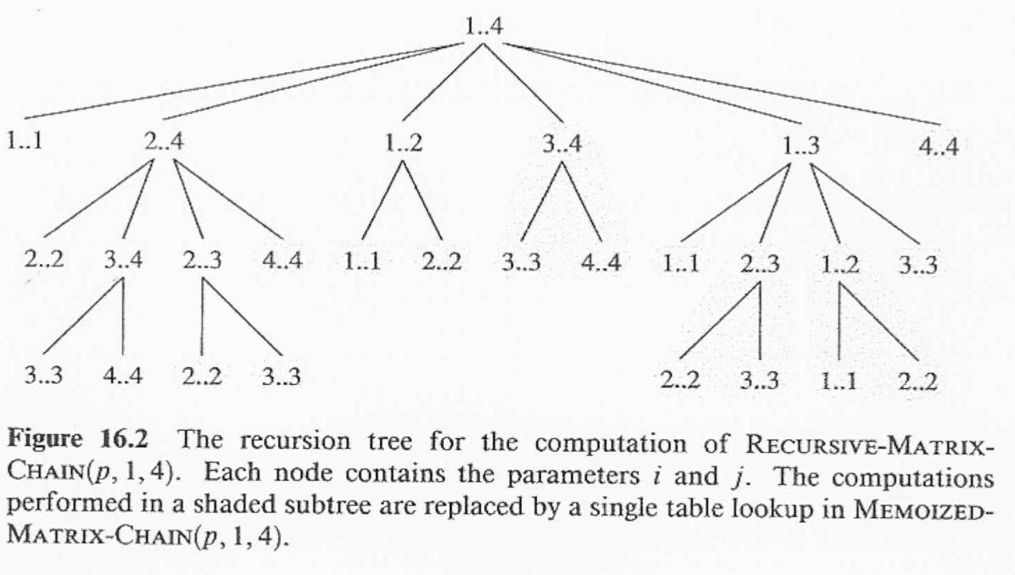

Figure 16.2 shows the recursion tree produced by the call RECURSIVE-MATRIX-CHAIN(p,1,4).

Each node is labeled by the values of the parameters i and j.

Observe that some pairs of values occur many times.

In fact, we can show that the running time T(n) to compute m[1, n] by this recursive procedure is at least exponential in n.

Let us assume that the execution of lines 1-2 and of lines 6-7 each take at least unit time.

Inspection of the procedure yields the recurrence

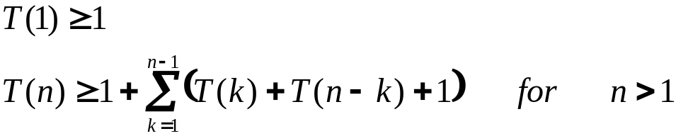

Noting that for i = 1, 2, . . ., n-1, each term T(i) appears once as T(k) and once as T(n - k), and collecting the n - 1 1's in the summation together with the 1 out front, we can rewrite the recurrence as

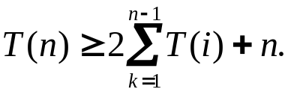 (16.4)

We shall prove that T(n) = .Ω(2^{n}) using the substitution method.

Specifically, we shall show that T(n)≥ 2^{n-1} for all n ≥ 1.

The basis is easy, since T(1) ≥ 1 = 2⁰.

Inductively, for n ≥ 2 we have

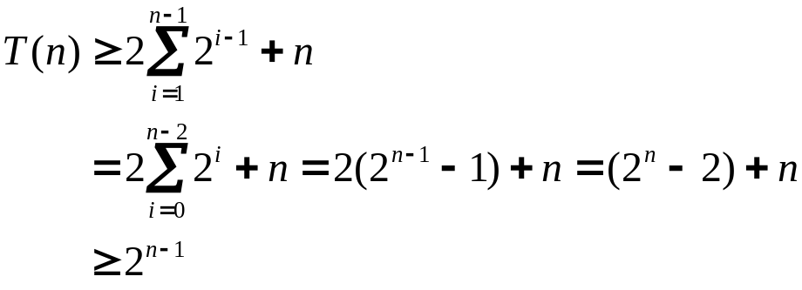

which completes the proof.

Thus, the total amount of work performed by the call RECURSIVE-MATRIX-CHAIN(p, 1, n) is at least exponential in n.

Compare this top-down, recursive algorithm with the bottom-up, dynamic-programming algorithm.

The latter is more efficient because it takes advantage of the overlapping-subproblems property.

There are only Θ(n²) different subproblems, and the dynamic-programming algorithm solves each exactly once.

The recursive algorithm, on the other hand, must repeatedly resolve each subproblem each time it reappears in the recursion tree.

Whenever a recursion tree for the natural recursive solution to a problem contains the same subproblem repeatedly, and the total number of different subproblems is small, it is a good idea to see if dynamic programming can be made to work.

Memoization

There is a variation of dynamic programming that often offers the efficiency of the usual dynamic programming approach while maintaining a top-down strategy.

The idea is to memoize the natural, but inefficient, recursive algorithm.

As in ordinary dynamic programming, we maintain a table with subproblem solutions, but the control structure for filling in the table is more like the recursive algorithm.

A memoized recursive algorithm maintains an entry in a table for the solution to each subproblem.

Each table entry initially contains a special value to indicate that the entry has yet to be filled in.

When the subproblem is first encountered during the execution of the recursive algorithm, its solution is computed and then stored in the table.

Each subsequent time that the subproblem is encountered, the value stored in the table is simply looked up and returned.

(This approach presupposes that the set of all possible subproblem parameters is known and that the relation between table positions and subproblems is established.)

Another approach is to memoize by using hashing with the subproblem parameters as keys.

The following procedure is a memoized version of
RECURSIVE-MATRIX- CHAIN.

MEMOIZED-MATRIX-CHAIN(p)

1. n ← length[p] - 1
2. for i ← 1 to n
3. do for j ← i to n
4. do m[i, j] ← ∞
5. return LOOKUP-CHAIN(p, 1, n)

LOOKUP-CHAIN(p, i, j)
1. if m[i,j] < ∞
2. then return m[i, j]
3. if i=j
4. then m[i, j] ← 0
5. else for k ← i to j - 1
6. do q ← LOOKUP-CHAIN(p, i, k)
+ LOOKUP-CHAIN(p, k + 1, j) + p_{i-1}p_{k}p_{j}
7. if q < m[i, j]
8. then m[i, j] ← q
9. return m[i, j]

MEMOIZED-MATRIX-CHAIN, like MATRIX-CHAIN-ORDER, maintains a table m[1 .. n, 1 .. n] of computed values of m[i, j], the minimum number of scalar multiplications needed to compute the matrix A_{i}.._{j}.

Each table entry initially contains the value ∞ to indicate that the entry has yet to be filled in.

When the call LOOKUP-CHAIN(p, i, j) is executed, if m[i,j] < ∞ in line 1, the procedure simply returns the previously computed cost m[i, j] (line 2).

Otherwise, the cost is computed as in RECURSIVE-MATRIX-CHAIN, stored in m[i, j], and returned.

(The value ∞ is convenient to use for an unfilled table entry since it is the value used to initialize m[i,j] in line 3 of RECURSIVE-MATRIX-CHAIN.)

Thus, LOOKUP-CHAIN(p, i ,j) always returns the value of m[i, j], but it only computes it if this is the first time that LOOKUP-CHAIN has been called with the parameters i and j.

Figure 16.2 illustrates how MEMOIZED-MATRIX-CHAIN saves time over RECURSIVE-MATRIX-CHAIN.

Shaded subtrees represent values that are looked up rather than computed.

Like the dynamic-programming algorithm MATRIX-CHAIN-ORDER, the procedure MEMOIZED-MATRIX-CHAIN runs in O(n³) time.

Each of Θ(n²) table entries is initialized once in line 4 of MEMOIZED-MATRIX-CHAIN and filled in for good by just one call of LOOKUP-CHAIN.

Each of these Θ(n²) calls to LOOKUP-CHAIN takes O(n) time, excluding the time spent in computing other table entries, so a total of O(n³) is spent altogether.

Memoization thus turns an Ω(2^{n}) algorithm into an O(n³) algorithm.

In summary, the matrix-chain multiplication problem can be solved in O(n³) time by either a top-down, memoized algorithm or a bottom-up, dynamic-programming algorithm.

Both methods take advantage of the overlapping-subproblems property.

There are only Θ(n²) different subproblems in total, and either of these methods computes the solution to each subproblem once.

Without memoization, the natural recursive algorithm runs in exponential time, since solved subproblems are repeatedly solved.

In general practice, if all subproblems must be solved at least once, a bottom-up dynamic-programming algorithm usually outperforms a top-down memoized algorithm by a constant factor, because there is no overhead for recursion and less overhead for maintaining the table.

Moreover, there are some problems for which the regular pattern of table accesses in the dynamic-programming algorithm can be exploited to reduce time or space requirements even further.

Alternatively, if some subproblems in the subproblem space need not be solved at all, the memoized solution has the advantage of only solving those subproblems that are definitely required.

16.3 Longest Common Sequence (LCS)

The next problem we shall consider is the longest common subsequence problem.

A subsequence of a given sequence is just the given sequence with some elements (possibly none) left out.

Formally, given a sequence X = ⟨x₁, x₂, …x_{m}⟩, another sequence Z = ⟨z₁, z₂, …, z_{k}⟩ is a subsequence of X if there exists a strictly increasing sequence ⟨i₁, i₂, …, i_{k}⟩ of indices of X such that for all j = 1, 2 , . . ., k, we have 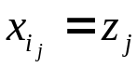.

For example, Z = ⟨B, C, D, B⟩ is a subsequence of X = ⟨A, B, C, B, D, A, B⟩ with corresponding index sequence ⟨2, 3, 5, 7⟩.

Given two sequences X and Y, we say that a sequence Z is a common subsequence of X and Y if Z is a subsequence of both X and Y.

For example, if X = ⟨A, B, C, B, D, A, B⟩ and Y = ⟨B, D, C, A, B, A⟩, the sequence ⟨B, C, A⟩ is a common subsequence of both X and Y.

The sequence ⟨B, C,A⟩ is not a longest common subsequence (LCS) of X and Y, however, since it has length 3 and the sequence ⟨B, C, B, A⟩, which is also common to both X and Y, has length 4.

The sequence ⟨B, C, B, A⟩ is an LCS of X and Y, as is the sequence ⟨B, D, A, B⟩, since there is no common subsequence of length 5 or greater.

In the longest-common-subsequence problem, we are given two sequences ⟨x₁, x₂, . . . , x_{m}⟩ and Y = ⟨y_{i}, y₂, . . . ,y_{n}⟩ and wish to find a maximum-length common subsequence of X and Y.

This section shows that the LCS problem can be solved efficiently using dynamic programming.

Characterizing a longest common subsequence

A brute-force approach to solving the LCS problem is to enumerate all subsequences of X and check each subsequence to see if it is also a subsequence of Y, keeping track of the longest subsequence found.

Each subsequence of X corresponds to a subset of the indices {1, 2, . . . , m} of X.

There are 2^{m} subsequences of X, so this approach requires exponential time, making it impractical for long sequences.

The LCS problem has an optimal-substructure property, however, as the following theorem shows.

As we shall see, the natural class of subproblems corresponds to pairs of "prefixes" of the two input sequences.

To be precise, given a sequence X =⟨x₁,x₂, . . ., x_{m}⟩, we define the i^{th} prefix of X, for i = 0, 1, . . . ,m, as X_{i} =⟨x₁,x₂, . . ., x_{i}⟩.

For example, if X = ⟨A, B, C, B, D, A, B⟩, then X₄ = ⟨A, B, C, B⟩ and X₀ is the empty sequence.

Theorem 16.1 (Optimal substructure of an LCS)

Let X = ⟨x₁, x₂, . . . , x_{m}⟩ and Y = ⟨y₁, y₂, . . .,y_{n}⟩ be sequences, and let Z = ⟨z₁, z₂, . . . ,z_{k}⟩ be any LCS of X and Y.

1. If x_{m}= y_{n}, then z_{k} = x_{m} =y_{n} and z_{k-l} is an LCS of X_{m-1} and Y_{n-1}

2. If x_{m} ≠ y_{n}, then z_{k} ≠ z_{m} implies that Z is an LCS of X_{m-1} and Y.

3. If x_{m} ≠ y_{n}, then z_{k} ≠ y_{n} implies that Z is an LCS of X and Y_{n-1}.

Proof
(1) If z_{k} ≠ x_{m}, then we could append x_{m} = y_{n} to Z to obtain a common subsequence of X and Y of length k + 1, contradicting the supposition that Z is a longest common subsequence of X and Y.

Thus, we must have z_{k} = x_{m} = y_{n}.

Now, the prefix Z_{k-1} is a length-(k - 1) common subsequence of x_{m-1} and y_{n-1}.

We wish to show that it is an LCS.

Suppose for the purpose of contradiction that there is a common subsequence W of X_{m-1} and Y_{n-1} with length greater than k - 1.

Then, appending x_{m} = y_{n} to W produces a common subsequence of X and Y whose length is greater than k, which is a contradiction.

(2) If z_{k} ≠ x_{m}, then Z is a common subsequence of X_{m-1} and Y.

If there were a common subsequence W of X_{m-1} and Y with length greater than k, then W would also be a common subsequence of X_{m} and Y, contradicting the assumption that Z is an LCS of X and Y.

(3) The proof is symmetric to (2).

The characterization of Theorem 16.1 shows that an LCS of two sequences contains within it an LCS of prefixes of the two sequences.

Thus, the LCS problem has an optimal-substructure property.

A recursive solution also has the overlapping-subproblems property, as we shall see in a moment.

A recursive solution to subproblems

Theorem 16.1 implies that there are either one or two subproblems to examine when finding an LCS of X = ⟨x₁, x₂, . . . ,x_{m}⟩ and Y = ⟨y₁, y₂, . . . y_{m}⟩.

If x_{m} = y_{n}, we must find an LCS of X_{m-1} and Y_{n-1} .

Appending x_{m} = y_{n} to this LCS yields an LCS of X and Y.

If x_{m} ≠ y_{n}, then we must solve two subproblems: finding an LCS of X_{m-1} and Y and finding an LCS of X and Y_{n-1}.

Whichever of these two LCS's is longer is an LCS of X and Y.

We can readily see the overlapping-subproblems property in the LCS problem.

To find an LCS of X and Y, we may need to find the LCS's of X and Y_{n-1} and of X_{m-1} and Y.

But each of these subproblems has the subsubproblem of finding the LCS of X_{m-1} and Y_{n-1} .

Many other subproblems share subsubproblems.

Like the matrix-chain multiplication problem, our recursive solution to the LCS problem involves establishing a recurrence for the cost of an optimal solution.

Let us define c[i, j] to be the length of an LCS of the sequences X_{i} and Y_{j}.

If either i = 0 or j = 0, one of the sequences has length 0, so the LCS has length 0.

The optimal substructure of the LCS problem gives the recursive formula

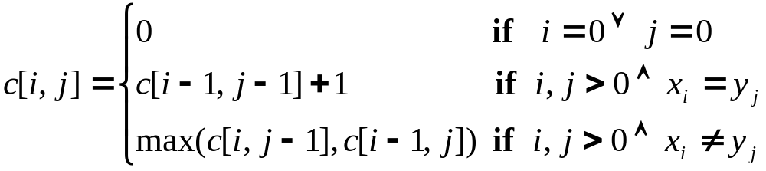(16.5)

Computing the length of an LCS

Based on equation (16.5), we could easily write an exponential-time recursive algorithm to compute the length of an LCS of two sequences.

Since there are only Θ(mn) distinct subproblems, however, we can use dynamic programming to compute the solutions bottom up.

Procedure LCS-LENGTH takes two sequences X = ⟨x₁, x₂, . . . ,x_{m}⟩ and y = ⟨y₁, y₂, . . .,y_{n}⟩ as inputs.

It stores the c[i,j] values in a table c[0.. m, 0. . n] whose entries are computed in row-major order. (That is, the first row of c is filled in from left to right, then the second row, and so on.)

It also maintains the table b[1 .. m, 1 .. n] to simplify construction of an optimal solution.

Intuitively, b[i, j] points to the table entry corresponding to the optimal subproblem solution chosen when computing c[i, j].

The procedure returns the b and c tables; c[m, n] contains the length of an LCS of X and Y.

Figure 16.3 shows the tables produced by LCS-LENGTH on the sequences X = ⟨A, B, C, B, D, A, B⟩ and Y =⟨B, D, C, A, B, A⟩.

The running time of the procedure is O(mn), since each table entry takes O(1) time to compute.

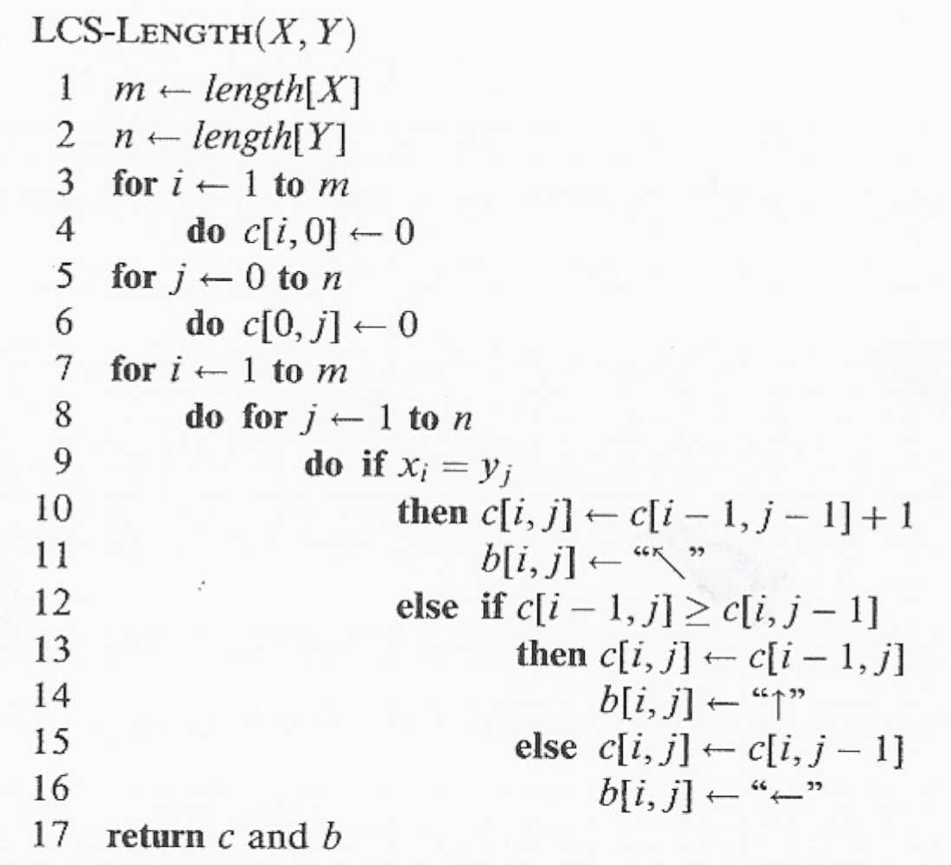

Constructing an LCS

The b table returned by LCS-LENGTH can be used to quickly construct an LCS of X = ⟨x₁,x₂, . . .,x_{m}⟩ and Y =⟨y₁, y₂, . . . ,y_{n}⟩.

We simply begin at b[m, n] and trace through the table following the arrows.

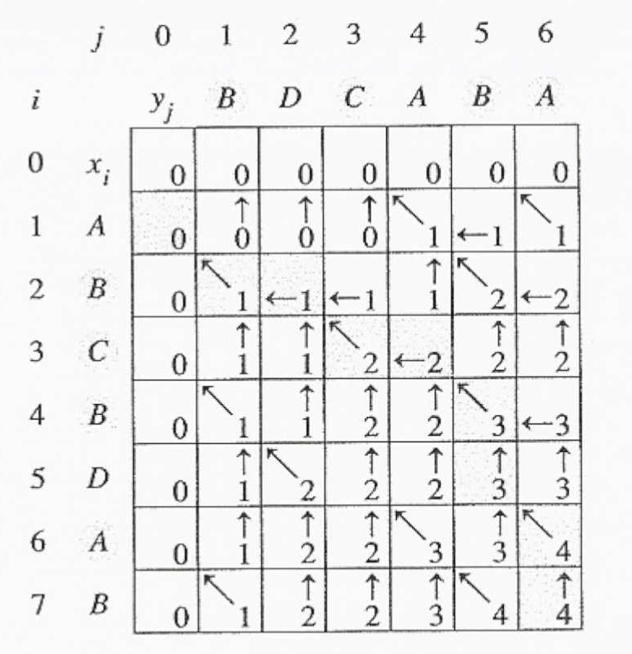
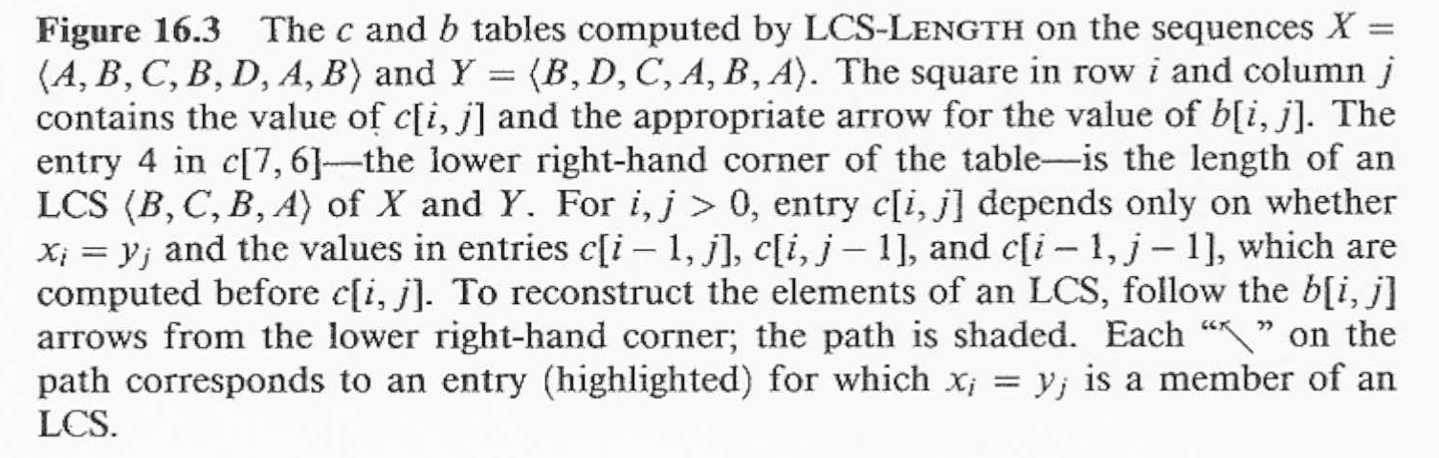

Whenever we encounter a back arrow in entry b[i, j], it implies that x_{i} = y_{j} is an element of the LCS.

The elements of the LCS are encountered in reverse order by this method.

The following recursive procedure prints out an LCS of X and Y in the proper, forward order.

The initial invocation is PRINT-LCS(b, X, length[X], length[Y]).

For the b table in Figure 16.3, this procedure prints"BCBA."

The procedure takes time O(m + n), since at least one of i and j is decremented in each stage of the recursion.

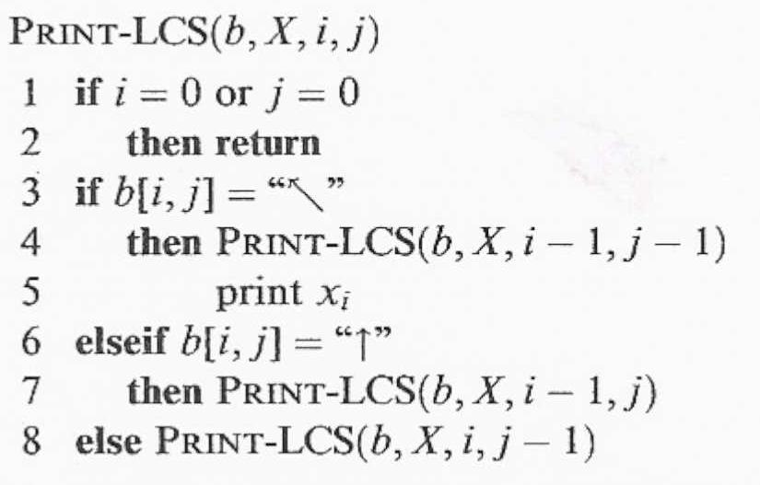

Improving the code

Once you have developed an algorithm, you will often find that you can improve on the time or space it uses.

This is especially true of straight-forward dynamic-programming algorithms.

Some changes can simplify the code and improve constant factors but otherwise yield no asymptotic improvement in performance.

Others can yield substantial asymptotic savings in time and space.

For example, we can eliminate the b table altogether. Each c[i,j] entry depends on only three other c table entries: c[i - l, j - 1], c[i - l, j], and c[i, j - 1].

Given the value of c[i,j], we can determine in 0(1) time which of these three values was used to compute c[i, j], without inspecting table b.

Thus, we can reconstruct an LCS in O(m + n) time using a procedure similar to PRINT-LCS. (Exercise 16.3-2 asks you to give the pseudocode.)

Although we save Θ(mn) space by this method, the auxiliary space requirement for computing an LCS does not asymptotically decrease, since we need Θ(mn) space for the c table anyway.

We can, however, reduce the asymptotic space requirements for LCS-LENGTH, since it needs only two rows of table c at a time: the row being computed and the previous row. (In fact, we can use only slightly more than the space for one row of c to compute the length of an LCS.

This improvement works if we only need the length of an LCS; if we need to reconstruct the elements of an LCS, the smaller table does not keep enough information to retrace our steps in O(m + n) time.

16.4 Optimal polygon triangulation

In this section, we investigate the problem of optimally triangulating a convex polygon.

Despite its outward appearance, we shall see that this geometric problem has a strong similarity to matrix-chain multiplication.

A polygon is a piecewise-linear, closed curve in the plane.

That is, it is a curve ending on itself that is formed by a sequence of straight-line segments, called the sides of the polygon.

A point joining two consecutive sides is called a vertex of the polygon.

If the polygon is simple, as we shall generally assume, it does not cross itself.

The set of points in the plane enclosed by a simple polygon forms the interior of the polygon, the set of points on the polygon itself forms its boundary, and the set of points surrounding the polygon forms its exterior.

A simple polygon is convex if, given any two points on its boundary or in its interior, all points on the line segment drawn between them are contained in the polygon's boundary or interior.

We can represent a convex polygon by listing its vertices in counterclockwise order.

That is, if P = ⟨υ_{O},υ₁ , . . . ,υ_{n-1}⟩ is a convex polygon, it has n sides (v₀, v₁), (v₁, v₂), …, (v_{n-1} v_{n}) where we interpret υ_{n} as υ₀. (In general, we shall implicitly assume arithmetic on vertex indices is taken modulo the number of vertices.)

Given two nonadjacent vertices υ_{i} and υ_{j}, the segment v_{i}v_{j} is a chord of the polygon.

A chord v_{i}v_{j} divides the polygon into two polygons: ⟨υ_{i}, υ_{i+ 1}, . . . ,υ_{j}⟩ and ⟨υ_{j},υ_{j+ 1}, . . . , υ_{i}⟩ .

A triangulation of a polygon is a set T of chords of the polygon that divide the polygon into disjoint triangles (polygons with 3 sides).

Figure 16.4 shows two ways of triangulating a 7-sided polygon.
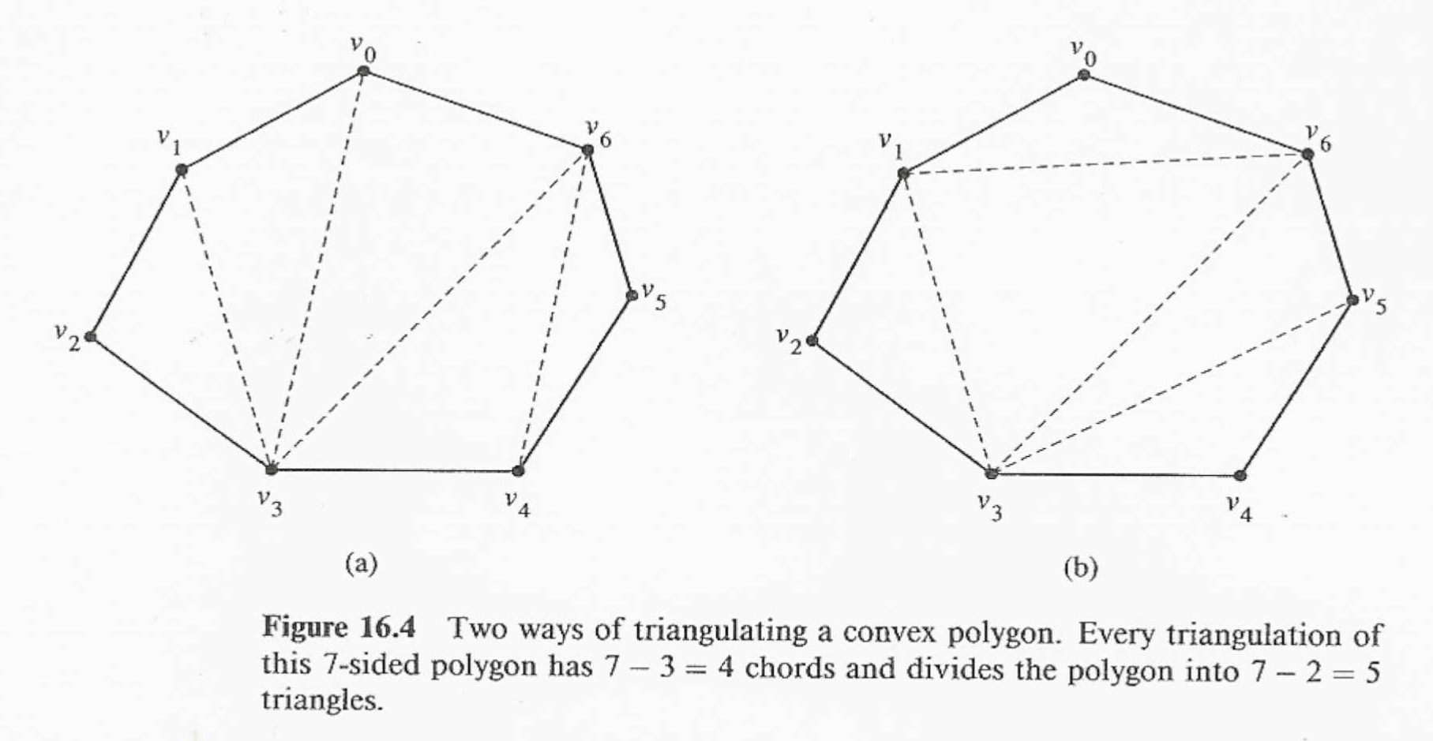

In a triangulation, no chords intersect (except at end-points) and the set T of chords is maximal: every chord not in T intersects some chord in T.

The sides of triangles produced by the triangulation are either chords in the triangulation or sides of the polygon.

Every triangulation of an n-vertex convex polygon has n - 3 chords and divides the polygon into n - 2 triangles.

In the optimal (polygon) triangulation problem, we are given a convex polygon P = ⟨υ₀, υ₁, . . . ,υ _{n-1}⟩ and a weight function ω defined on triangles formed by sides and chords of P.

The problem is to find a triangulation that minimizes the sum of the weights of the triangles in the triangulation.

One weight function on triangles that comes to mind naturally is

ω(Δ υ₁υ_{j}υ_{k}) = |υ_{i}υ_{j}| + |υ_{j}υ_{k}| + |υ_{k}υ_{i}| ,

where |υ_{i}υ _{j}| is the euclidean distance from υ_{i} to υ_{j}.

The algorithm we shall develop works for an arbitrary choice of weight function.

Correspondence to parenthesization

There is a surprising correspondence between the triangulation of a polygon and the parenthesization of an expression such as a matrix-chain product.

This correspondence is best explained using trees.

A full parenthesization of an expression corresponds to a full binary tree, sometimes called the parse tree of the expression.

Figure 16.5(a) shows a parse tree for the parenthesized matrix-chain product

((A₁ (A₂A₃))(A₄(A₅A₆))) .

Each leaf of a parse tree is labeled by one of the atomic elements (matrices) in the expression.

If the root of a subtree of the parse tree has a left subtree representing an expression E_{l} and a right subtree representing an expression E_{r}, then the subtree itself represents the expression (E_{l}E_{r}).

There is a one-to-one correspondence between parse trees and fully parenthesized expressions on n atomic elements.

A triangulation of a convex polygon ⟨υ₀, υ₁, . . . ,υ _{n-1}⟩ can also be represented by a parse tree.

Figure l6.5(b) shows the parse tree for the triangulation of the polygon from Figure l6.4(a).

The internal nodes of the parse tree are the chords of the triangulation plus the side v0v6, which is the root.

The leaves are the other sides of the polygon.

The root v₀v₆ is one side of the triangle Δv₀v₃v₆.

This triangle determines the children of the root: one is the chord v₀v₃, and the other is the chord v₃v₆.

Notice that this triangle divides the original polygon into three parts: the triangle Δυ₀υ₃υ₆ itself, the polygon ⟨υ₀υ₁, . . . ,υ υ₃⟩, and the polygon⟨υ₃υ₄, . . . ,.υ₆⟩.

Moreover, the two sub-polygons are formed entirely by sides of the original polygon, except for their roots, which are the chords v₀v₃ and v₃v₆.

In recursive fashion, the polygon ⟨υ0,υ1 , . . . , υ3⟩ contains the left subtree of the root of the parse tree, and the polygon ⟨υ3, υ4, . . . , υ6⟩ contains the right subtree.

In general, therefore, a triangulation of an n-sided polygon corresponds to a parse tree with n - 1 leaves.

By an inverse process, one can produce a triangulation from a given parse tree.

There is a one-to-one correspondence between parse trees and triangulations.

Since a fully parenthesized product of n matrices corresponds to a parse tree with n leaves, it therefore also corresponds to a triangulation of an (n + 1)-vertex polygon.

Figures 16.5(a) and (b) illustrate this correspondence.
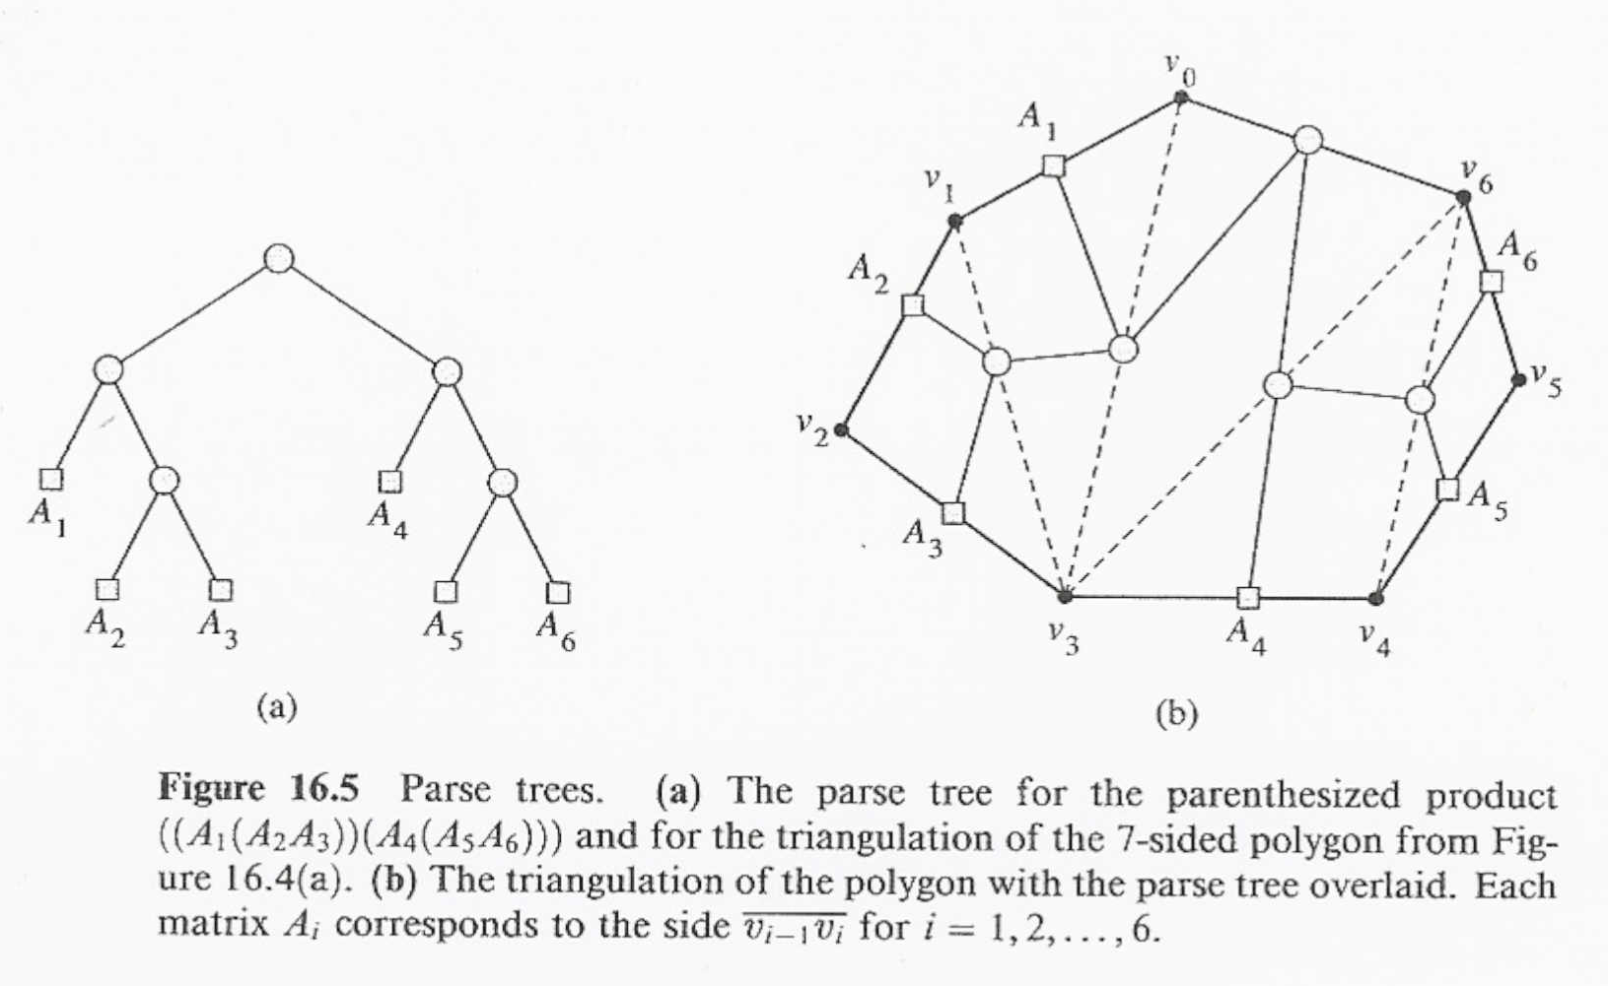

Each matrix A_{i} in a product A₁A₂ . . . A_{n} corresponds to a side v_{i-1}v_{i} of an (n + 1)-vertex polygon.

A chord v_{i}v_{j}, where i < j, corresponds to a matrix A_{i+1}.._{j} computed during the evaluation of the product.

In fact, the matrix-chain multiplication problem is a special case of the optimal triangulation problem.

That is, every instance of matrix-chain multiplication can be cast as an optimal triangulation problem.

Given a matrix-chain product A₁A₂...A_{n}, we define an (n + 1)-vertex convex polygon P =⟨υ₀, υ₁, . . . , υ_{n}⟩.

If matrix A_{i} has dimensions p_{i-1} x p_{i} for i = 1, 2, . . . , n, we define the weight function for the triangulation as

ω(Δυ_{i}υ_{j}υ_{k}) = p_{i}p_{j}p_{k} .

An optimal triangulation of P with respect to this weight function gives the parse tree for an optimal parenthesization of A₁A₂ . . . A_{n}.

Although the reverse is not true--the optimal triangulation problem is not a special case of the matrix-chain multiplication problem--it turns out that our code MATRIX-CHAIN-ORDER, with minor modifications, solves the optimal triangulation problem on an (n + 1)-vertex polygon.

We simply replace the sequence ⟨p₀, p₁, . . ., p_{n}⟩ of matrix dimensions with the sequence ⟨υ₀, υ₁, . . . , υ_{n}⟩ of vertices, change references to p to references to υ, and change line 9 to read:

9 q ← m[i, k] + m[k + l, j] + ω(Δυ_{i-1}υ_{k}υ_{j})

After running the algorithm, the element m[1, n] contains the weight of an optimal triangulation.

Let us see why this is so.

The substructure of an optimal triangulation

Consider an optimal triangulation T of an (n + 1 )-vertex polygon P = ⟨υ₀, υ₁, . . . ,υ_{n}⟩ that includes the triangle Δυ₀υ_{k}υ_{n} for some k, where 1 ≤ k ≤ n - 1.

The weight of T is just the sum of the weights of Δυ₀υ_{k}υ_{n} and triangles in the triangulation of the two sub-polygons ⟨υ₀, υ₁, . . . , υ_{k}⟩ and ⟨υ_{k}, υ_{k} ₊ ₁, . . . , υ_{n}⟩.

The triangulations of the sub-polygons determined by T must therefore be optimal, since a lesser-weight triangulation of either sub-polygon would contradict the minimality of the weight of T.

A recursive solution

Just as we defined m[i, j] to be the minimum cost of computing the matrix-chain sub-product A_{i}A_{i+1} . . . A_{j}, let us define t[i, j], for 1 ≤ i < j ≤ n, to be the weight of an optimal triangulation of the polygon ⟨υ_{i-1}, υ_{i}, . . . , υ_{j}⟩.

For convenience, we consider a degenerate polygon ⟨υ_{i -1}, υ_{i}⟩ to have weight 0.

The weight of an optimal triangulation of polygon P is given by t[l, n].

Our next step is to define t[i,j] recursively.

The basis is the degenerate case of a 2-vertex polygon: t[i, i] = 0 for i = 1, 2, . . . , n.

When j - i ≥ 1, we have a polygon ⟨υ_{i} _{– 1}, υ_{i}, . . . ,υ_{j}⟩ with at least 3 vertices.

We wish to minimize over all vertices υ_{k}, for k = i, i + 1 , . . . , j - 1, the weight of Δυ_{i – 1} υ_{k}υ_{j} plus the weights of the optimal triangulations of the polygons ⟨υ_{i – 1}, υ_{i}, . . . , υ_{k}⟩ and ⟨υ_{k}, υ_{k + 1} , . . . , υ_{j}⟩.

The recursive formulation is thus

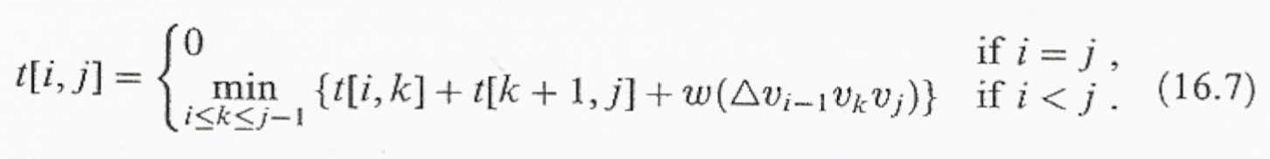

Compare this recurrence with the recurrence (16.2) that we developed for the minimum number m[i, j] of scalar multiplications needed to compute A_{i}A_{i+1} . . . Aj.

Except for the weight function, the recurrences are identical, and thus, with the minor changes to the code mentioned above, the procedure MATRIX-CHAIN-ORDER can compute the weight of an optimal triangulation.

Like MATRIX-CHAIN-ORDER, the optimal triangulation procedure runs in time Θ(n³) and uses Θ(n²) space.

